Session 15 : SCTP & Quality of Service

RECAP: Session 14 : TCP: Data, Flow & Congestion

Agenda for Today's Session
- SCTP — Features, Multi-Streaming & Multi-Homing
- SCTP vs TCP vs UDP
- Quality of Service (QoS) — Parameters & Techniques
- IntServ, DiffServ & Switched Networks

--------------------------------------- SECTION 1: SCTP — Features, Multi-Streaming & Multi-Homing ---------------------------------------

Slide 1: Why SCTP Exists — TCP's Two Problems
Heading: Why was SCTP Created?
Subheading: Two Problems TCP Could Not Solve
Content:
Problem 1 — Head-of-Line (HOL) Blocking:
- TCP delivers data as one ordered stream. If one segment is lost, all segments behind it wait — even if they already arrived correctly.
- Example: Three images requested. Image 2's packet is lost. Image 3 is stuck waiting even though it arrived fine.
Problem 2 — Single Path Dependency:
- TCP binds a connection to one IP address per side.
- If that path fails, the entire connection drops and must restart from scratch.
- Critical problem for telecom signaling where availability cannot be interrupted.
SCTP was designed to fix these two problems. It was originally built for telecom networks — the systems that manage phone calls and routing between telephone exchanges.
Analogy: TCP is a single-lane road — one broken-down car blocks everyone. SCTP opens multiple lanes; a blockage in one lane does not stop the others.
Visual Guidance: Left: TCP — one stream, one path, blocked queue. Right: SCTP — 3 independent streams, 2 paths (Path A primary, Path B standby).
Speaker Notes: "TCP has two limitations that matter in telecom. First, head-of-line blocking — one lost packet holds up everything behind it. Second, single path dependency — if the network path fails, the connection dies completely. SCTP was built to fix exactly these two problems."

Slide 2: SCTP — What It Is & Key Features
Heading: SCTP — Stream Control Transmission Protocol
Subheading: A Smarter Transport Protocol
Content:
SCTP is a connection-oriented, reliable Transport Layer protocol — like TCP, but with two additional capabilities.
Feature 1 — Multi-Streaming:
- One association carries multiple independent streams.
- A loss in Stream 1 does NOT block Stream 2 or Stream 3.
- Each stream has its own Stream Sequence Number (SSN).

Feature 2 — Multi-Homing:
- Both endpoints register multiple IP addresses at association setup.
- One is the Primary Path; others are Standby Paths.
- SCTP sends Heartbeat chunks to monitor standbys.
- If primary fails → automatically switches to standby. No reconnection needed.
Analogy for Multi-Streaming:Think of a WhatsApp chat — you are sending a photo, a voice note, and a text at the same time. If the photo upload stalls, the text and voice note still go through. Each is its own independent stream.
Analogy for Multi-Homing: Think of your phone — it has both WiFi and mobile data. If the WiFi drops, your call or video doesn't disconnect — it silently switches to mobile data and continues. You barely notice. That is exactly what SCTP Multi-Homing does at the network level.
Feature | Detail
Standard | RFC 4960
Connection term | Association (not "connection")
Data unit | Chunk (not "segment")
Handshake | 4-Way (INIT → INIT-ACK → COOKIE-ECHO → COOKIE-ACK)
Reliability | Yes — like TCP
Multi-Streaming | Yes — solves HOL Blocking
Multi-Homing | Yes — solves single path failure
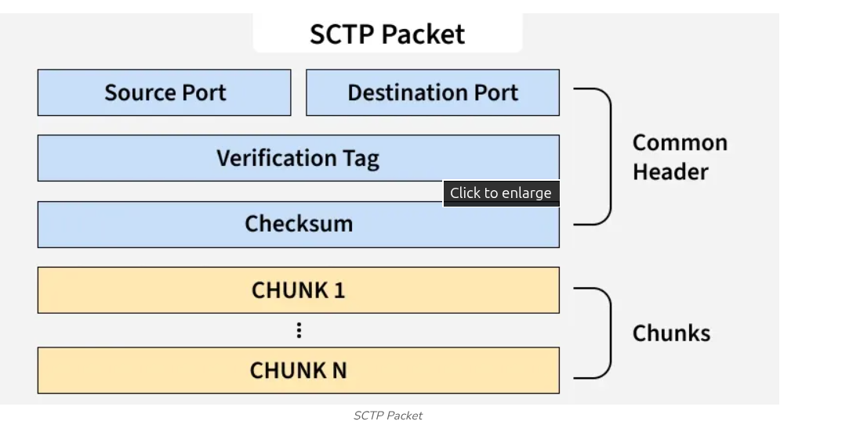
Where SCTP is Used: SCTP is used in 4G/5G mobile networks (to manage signaling between towers and core network), WebRTC (real-time browser communication like Google Meet), and telecom backbone networks.

Visual Guidance: Top diagram: SCTP Association → 3 streams; Stream 1 marked "⚠ Retransmitting," Streams 2 & 3 marked "✓ Delivering." Bottom diagram: Two hosts with 2 IPs each — Path 1 (❌ failed), Path 2 (✓ active).
Speaker Notes: "SCTP sits at the Transport Layer alongside TCP and UDP. Its connection is called an Association; data units are Chunks. Multi-Streaming means one association runs multiple independent streams — a lost packet in one stream does not affect the others. Multi-Homing means both sides register backup IPs at setup. SCTP monitors them with heartbeats and silently switches to a backup if the primary fails. This is what makes SCTP invaluable in 5G and telecom networks."

--------------------------------------- SECTION 2: SCTP vs TCP vs UDP ---------------------------------------

Slide 3: SCTP 4-Way Handshake
Heading: SCTP
Subheading: 4-Way Handshake:
Content:
Step | Message | Direction | Purpose
1 | INIT | Client → Server | Request association; share IPs & stream count
2 | INIT-ACK | Server → Client | Respond with a Cookie token
3 | COOKIE-ECHO | Client → Server | Echo the cookie back
4 | COOKIE-ACK | Server → Client | Cookie verified; association open
Why Cookie?
Server allocates no resources until the cookie is echoed back. Fake INIT messages cannot exhaust server memory.This protects against a DoS (Denial of Service) attack — where an attacker sends thousands of fake connection requests to crash the server by exhausting its memory. Since SCTP's server stores nothing until the cookie is echoed back, fake requests cause no harm.

SCTP vs TCP vs UDP:
Feature | UDP | TCP | SCTP
Connection | No | Yes | Yes (Association)
Reliability | No | Yes | Yes
Multi-Streaming | No | No | Yes
Multi-Homing | No | No | Yes
HOL Blocking | N/A | Yes | No
Handshake | None | 3-Way | 4-Way + Cookie
DoS Protection | No | Weak | Built-in
Use Cases | DNS, VoIP, games | HTTP, files, email | 5G, telecom, WebRTC
Visual Guidance: Ladder diagram for 4-way handshake with note at Step 2: "Server stores no state yet." Below: the comparison table with SCTP column highlighted.
Speaker Notes: "The extra step in the 4-way handshake is the Cookie. The server sends a stateless token and only commits resources when the client echoes it back — a clean protection against SYN flood attacks. The table shows SCTP adds multi-streaming and multi-homing on top of TCP's reliability, at slightly higher overhead. Choose UDP for speed, TCP for general reliability, SCTP when you need reliability plus path fault-tolerance."

--------------------------------------- SECTION 3: Quality of Service (QoS) — Parameters & Techniques ---------------------------------------

Slide 4: What is QoS & Its Parameters
Heading: Quality of Service (QoS)
Subheading: Not All Traffic is Equal
Content:
At the same time on your network:
- A video call needs smooth, real-time delivery — delay kills it.
- A software update runs in the background — a few extra seconds do not matter.
Without QoS, the network treats both identically. The video call suffers.
QoS = Ability of a network to manage traffic and provide different levels of service to different types of data — ensuring critical, time-sensitive applications like voice calls and video get the resources they need, especially when the network is busy.
Four QoS Parameters:
Parameter | What It Measures | Most Critical For
Delay | Time from source to destination | VoIP (< 150ms per ITU-T G.114)
Jitter | Variation in delay between packets | Streaming, VoIP
Bandwidth | Available data rate on a path | Video streaming
Packet Loss | % of packets never delivered | VoIP, real-time apps
Jitter in brief: Packets sent at equal intervals but arriving unevenly (10ms, 25ms, 12ms) → choppy audio. Fixed using a Jitter Buffer at the receiver.
Analogy : Think of a hospital emergency room — a heart attack patient is attended to immediately, while a minor cut can wait. The doctor decides who gets priority based on urgency. QoS does the same for network traffic — urgent data goes first.
Visual Guidance: Router in centre. Three traffic types entering: Video Call (red), Software Update (blue), Streaming (green). Video Call gets a wider output lane. Label: "QoS — Priority Based Service."
Speaker Notes: "QoS recognises that not all traffic has the same urgency. A video call cannot tolerate delay or jitter — even 200ms one-way makes a call feel unnatural. A background download has no such issue. QoS gives the network a way to identify and act on urgency. Delay, jitter, bandwidth, and packet loss are the four parameters we use to measure whether QoS goals are being met."

Slide 5: QoS Techniques — Packet Scheduling & Traffic Shaping
Heading: QoS Techniques
Subheading: Scheduling and Traffic Shaping
Content:
A — Scheduling: Who Gets Served First?
Method | How It Works | Note
FIFO | First in, first out. No priority. | Unfair to real-time traffic
Priority Queuing | High-priority queue served first | Low-priority can starve
Weighted Fair Queuing (WFQ) | Each queue gets a % share (Voice 50%, Video 30%, Data 20%) | No starvation; balanced
Round Robin | One packet per queue in turns | Equal turns; ignores urgency
Modern routers use WFQ — everyone gets a share, priority classes get more.
Analogy: Priority Queuing = First Class boards the plane first. WFQ = Each class gets a reserved number of seats — no one is left out entirely.

B — Traffic Shaping: Control the Rate
Leaky Bucket:
- Input: bursty packets → Output: constant, fixed rate. Overflow → packets dropped.
- Think of a water tank with a small hole at the bottom — no matter how fast you fill water from the top, water flows out only at a fixed, slow rate. Pour too much too fast — it overflows and spills (packets dropped)
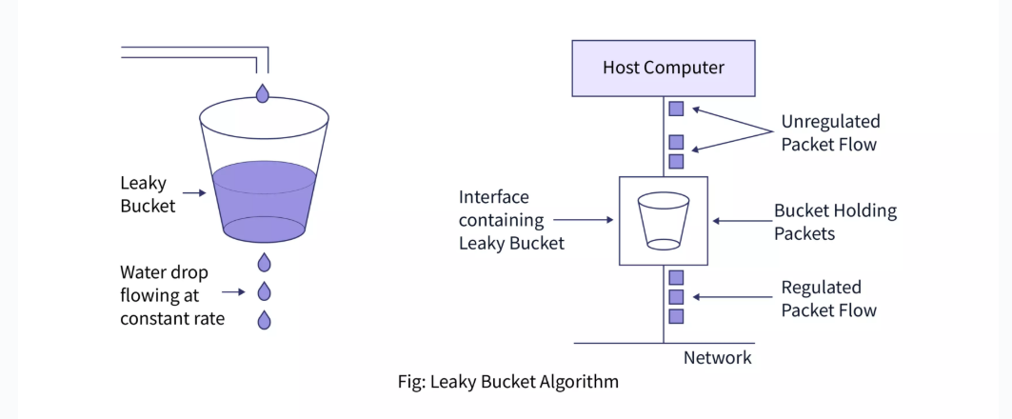
Token Bucket:
- Tokens added at a constant rate. One token = send one packet. Saved tokens allow a controlled burst.
- More flexible — allows short bursts when the network can handle it.
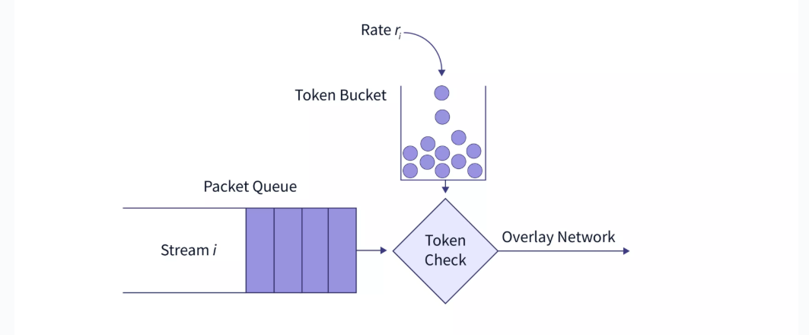
Parameter | Leaky Bucket | Token Bucket
Output | Always constant | Can burst (up to bucket size)
Excess | Dropped | Waits for a token
Best for | Strict rate enforcement | Allow bursts within bounds
Visual Guidance: Two diagrams — Leaky Bucket (bursty in, steady drip out) and Token Bucket (tokens accumulating, burst of packets released).
Speaker Notes: "Scheduling decides priority at the router queue — WFQ is the practical standard. Traffic Shaping controls the rate before data enters the network. Leaky Bucket enforces a strict constant rate, excess is dropped. Token Bucket is more lenient — save tokens and send a burst, but average rate is capped. ISPs use these to enforce bandwidth limits on customer plans."

--------------------------------------- SECTION 4: IntServ, DiffServ & QoS in Switched Networks ---------------------------------------
Slide 6: Two Approaches to Network-Wide QoS
Heading: How Does a Network Guarantee Quality?
Subheading: Three Approaches — Best Effort, IntServ & DiffServ
Content:
Once we know QoS parameters and techniques, the next question is:

How does the entire network — across multiple routers — ensure quality end to end?
Three architectures answer this:
Approach | Full Name | Core Idea
Best Effort | Best Effort | No guarantee — deliver when possible. Default internet behaviour.
IntServ | Integrated Services | Reserve resources per flow before sending
DiffServ | Differentiated Services | Mark traffic into classes, treat each class consistently

—--------------------------------------------------------------------------------------------------------

Here is the complete Best Effort slide:

Slide 6: Best Effort — The Default Behaviour

Heading: Best Effort

Subheading: How the Internet Works by Default

Content:

By default, the internet makes no guarantees about how or when a packet will be delivered. This is called Best Effort delivery.

No priority — every packet is treated equally

No reservation — no resources are set aside for any traffic

No guarantee — packets may be delayed, dropped, or delivered out of order

The network simply does its best to deliver data whenever possible

This works fine for:

Emails, File downloads, General web browsing

This fails for:

Live video calls,VoIP (voice calls over internet), Real-time applications

This is exactly why IntServ and DiffServ were introduced — to improve upon Best Effort for time-sensitive traffic.

Analogy: General compartment in a train — no reservation, no guarantee. If there is space, you sit. If not, you stand. The railway makes no promise.

Visual Guidance: Show a router with multiple packets entering — all treated the same, no priority lanes, no labels. Some packets shown getting dropped. Label: "Best Effort — No Guarantee."

Speaker Notes: "Before we study IntServ and DiffServ, it is important to understand what the internet does by default — Best Effort. No priority, no reservation, no guarantee. Your packet goes in and the network tries its best to deliver it. For emails and downloads this is perfectly fine. But for a live video call, even a small delay or drop ruins the experience. This is the problem that IntServ and DiffServ were both designed to solve."

Slide 7: IntServ & DiffServ
Heading: Three Approaches to Network-Wide QoS
Subheading : Integrated Services (IntServ)
Content:
(Per-Flow Reservation):
- Application reserves resources (bandwidth + delay) along the entire path before sending.
- Protocol: RSVP — PATH message downstream to receiver; RESV message upstream, each router reserves resources.
- Service types: Guaranteed (hard delay bound) and Controlled Load (behaves like lightly loaded network).
- Problem: Every router stores state for every active flow → not scalable at internet scale.
Analogy: Think of a reserved compartment in a train — before the journey, you book a specific seat. The railway guarantees that seat is yours — no one else can take it. You know exactly where you will sit and when you will reach. But imagine if every single passenger on every train demanded a personal reservation — the booking system would collapse under the load.

DiffServ — Differentiated Services (Per-Class Treatment):
- No per-flow tracking. Traffic sorted into classes at the network edge.
- Edge router marks each packet with a DSCP value (6-bit field in IP header).
- Core routers only read the DSCP label and forward — no flow memory needed. Highly scalable.

Analogy for DiffServ: Think of a highway with 3 lanes — an Express lane (ambulances, VIP vehicles), a Fast lane (regular cars), and a Slow lane (trucks). Every vehicle is assigned a lane based on its type — not its individual identity. In DiffServ, the DSCP value is exactly this lane tag — it tells every router which lane this packet belongs to. A VoIP packet gets the Express lane (EF), a video stream gets the Fast lane (AF), and a file download gets the Slow lane (BE). Routers don't remember individual packets — they just read the lane tag and act.
Traffic Classes in DiffServ
Class | Name | Use
EF | Expedited Forwarding | VoIP, real-time — lowest delay
AF | Assured Forwarding | Video, priority data — bounded delay
BE | Best Effort | General browsing — no guarantee
IntServ vs DiffServ:
 | IntServ | DiffServ
Granularity | Per-flow | Per-class
Scalability | Poor | Excellent
Guarantee | Hard | Soft
Protocol | RSVP | DSCP marking
Use case | Small managed networks | Internet & enterprise

Visual Guidance: Left — IntServ: PATH/RESV ladder, each router marked "Reserves Bandwidth." Right — DiffServ: edge router marks DSCP → core routers read label → three output lanes (EF, AF, BE).
Speaker Notes: "IntServ is the strict approach — reserve bandwidth per flow at every router. Hard guarantees but cannot scale to millions of flows. DiffServ is the practical internet solution — mark packets with a class label at the edge, core routers just forward by label. No state, no flow tracking, fully scalable. DiffServ runs enterprise and ISP networks today."

Slide 8: QoS in Switched Networks

Heading: QoS in Switched Networks (Local Network)
Subheading: How Switches Prioritise Traffic

Content:
So far we saw QoS across the internet (IntServ, DiffServ). But QoS also works inside a local network — within your college, office, or data centre — using Ethernet switches.
How Does a Switch Know Which Traffic is Priority?
Ethernet uses a standard called IEEE 802.1p to mark priority inside a local network.
- Every Ethernet frame can carry a VLAN tag (802.1Q).
- Inside this tag, there is a 3-bit field called PCP (Priority Code Point).
- 3 bits = 8 priority levels (0 to 7), where 7 is highest and 0 is lowest.
Priority Level Mapping:
Priority Level | Traffic Type
7 | Network control traffic
5 – 6 | VoIP calls, video conferencing
3 – 4 | Business critical applications
0 – 2 | General data, best effort
How It Works:
- When a VoIP packet enters the switch, it is tagged with PCP = 6.
- When a file download enters the switch, it is tagged with PCP = 0.
- The switch reads this PCP value and serves higher priority frames first from its queue.
- Result — even on a busy office network, voice calls stay clear.
Analogy: Think of a busy school canteen with a separate express counter for teachers. Students wait in the regular queue. Teachers walk straight to the express counter and get served first. The canteen does not need to know each teacher's name — just their identity tag (PCP value) tells the staff to serve them first.
Visual Guidance: Show an Ethernet frame structure with the 802.1Q VLAN tag highlighted. Inside the tag, zoom in to show the 3-bit PCP field. Next to it, show a switch with two queues — High Priority (VoIP, PCP=6) served first, Low Priority (file download, PCP=0) served after.
Speaker Notes: "QoS is not just for wide area networks — it works inside your local network too. Ethernet switches use a 3-bit priority field called PCP inside the VLAN tag. This gives 8 priority levels. VoIP and video are tagged with high priority values and the switch always serves them first. A file download gets priority 0 and waits. This is how offices and data centres ensure that voice calls and video meetings stay smooth even when the network is busy with other traffic."

End of TR Doc 15
key takeaways
—----------------------------------------------------------------------------------------------------------------------------Upcoming Session : Network Layer & IP Addressing

